Collections Emergency Documentation Activity – Numbering
- Review the scenario.
  - An unsecured ladder in your collections workroom fell over and tipped a table of new acquisitions over the weekend. You walk in Monday morning to several uncatalogued collection items scattered all over the floor. The collection items are from a formal dinner place setting (like the image below) which includes silverware, plates of various sizes, linens, and glasses. By some miracle, only one plate broke from the fall. The collection items do not have images or catalog numbers written on them.
- Establish a tracking number system.
  - Assign Collections Emergency Tracking Numbers to each item. Be sure you can explain the logic behind your system to a new person. It should be simple and easy to follow.
  - Think about how you would keep the emergency tracking numbers associated with the collection items.
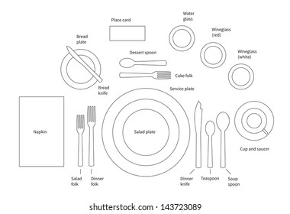

Collections Emergency Documentation Activity – Numbering and Gridding

- Review the Scenario. Scenario: A flash flood hits the museum collections areas with no time to evacuate collection items. The force of water is so strong it damages the museum’s ENTIRE storage facility. All original numbers have been washed away. Computers have been damaged, and the internet is down, so you cannot access your electronic database. The salvage teams have been cleared to enter the site and are waiting for documentation standards before beginning the salvage.
- Create a gridding system. Go to https://www.collabshot.com/ and scroll down to “Try Collabshot Instantly.” Upload the Room Layout.jpg document and draw a grid on top of the room. Create a system for labeling the grid. Remember this is how you will document the found location of the items extracted. Be sure you can explain the logic behind your system to a new person. It should be simple and easy to follow.
- Establish a tracking number system. Remember this is a temporary number that will be used to identify the collection item throughout the emergency response and recovery operations, or until it can be reconciled with its original number. Be sure you can explain the logic behind your system to a new person. It should be simple and easy to follow.
- Practice your emergency documentation systems. Break-out room facilitators rotate. With your new facilitator, test your emergency tracking system. Communicate your system to them as though it is the end of your shift, and you are handing off your duties to the next team(s) coming in to continue the work of emergency documentation and salvage.
Collections Emergency Tracking Sheet
Instructions: Use the template below to practice your emergency documentation numbering and gridding systems. In the sheet, are the high-priority items. Document these items by filling out the tracking numbers and found locations below.
Tracking No. | Original No. | Brief Object Description | Material Type | Damage / Condition | Found Location | New Location | Image #s
 |  | Tiger | Skin, fur, teeth, plastic, unknown stuffing | Damp
 |  | Clothing articles | Fabric, various | Wet, dye bleeding
 |  | Coins and medals | Metals, fabric | Wet
 |  | Pottery, pottery shards | Pottery | Dried, broken
 |  | Books | Paper, leather, glue | Some damp
 |  | Chuckwagon | Wood, cloth, metal, leather | Damp, wheels wet
Sheet No: ________ Date: ____________________ Performed by: ___________________________

Emergency Location: _______________________________________________________ Emergency Date: _______________
Emergency Type/Description: ___________________________________________________________________________________
Image Log Description: ________________________________________________________________________________________
Optional Activity Information

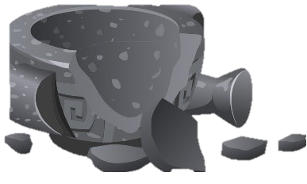 | Significant portions of the pottery collection have fallen from shelves and broken into shards. Many of the vessels are now intermixed as broken sherds. This area of the collection space was previously flooded but is now dry.
 | Parts of the numismatic collection have fallen out of the drawers and are laying on the floor. They have lost association with their drawers and item numbers, and were previously wet, but have now dried.
 | Clothing was stored on hangars on a clothing rack in a collections row are now scattered across the entire aisle, submerged in water. Some of the fabrics are bleeding into the water, and the dye runs the risk of bleeding onto other objects. Most of these objects are not of high value to the museum.
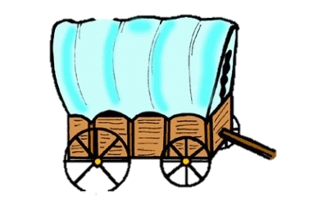 | The 1850s chuckwagon is the museum’s most valuable object. The force of the earthquake moved it from its seated position to where it is now blocking an aisle. Its wheels are sitting in water, and the tarp top and sides are damp to touch, but the object is otherwise unharmed.
 | The taxidermy tiger is on loan from another institution. It is damp to the touch, and plaster dust has covered the mount.
 | Some objects of the book collection have fallen from their shelves, but most of the collection did not sustain damage. The books were impacted by water, some more than others.

